Manila Water Company
TECHNICAL SPECIFICATION – Report

DID_M2C_056

Enhancement for Group Accounts Invoice Summary

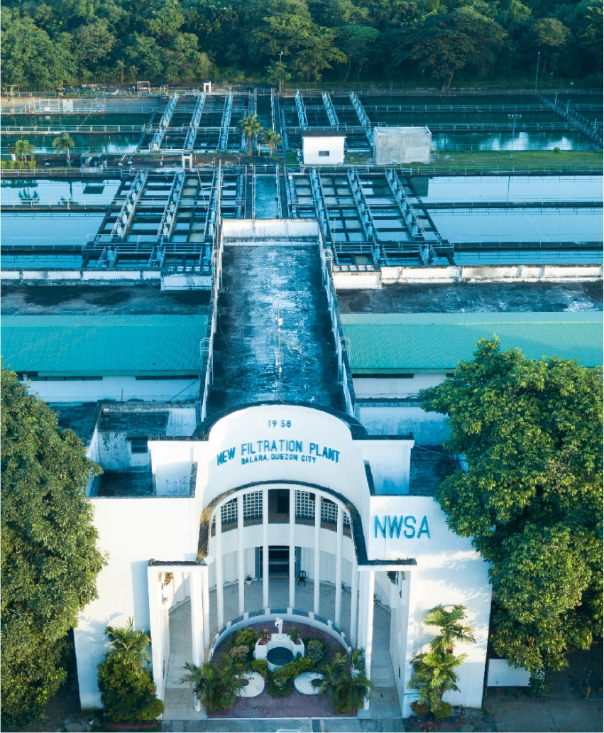

Contents
1 Document Organization 4
1.1 Document Log 4
1.2 Integration, Document Reference 4
2 Program Attributes 5
2.1 Authorization Requirements 6
2.1.1 Definition 6
2.1.2 Defined Fields 7
2.1.3 Procedure 7
2.2 Technical Flow Diagram 7
2.3 Processing Logic 7
2.4 Error handling 7
2.5 BRF Details 7
2.6 Fiori Extension 7
2.7 Cloud Extension 7
2.8 Custom DDIC Objects 8
2.9 Custom Business Object Details 8
2.10 Custom CDS Views Details 8
2.11 Custom Field details 8
2.12 Custom Logic/Enhancement Details 9
2.13 Custom Reusable Elements (Code-list, Library) 9
2.14 Form & Email Extensibility 9
2.15 Messages 10
2.16 Subroutines 10
3 Assumptions in Technical Design 10
4 Open Issues in Technical Design 10
5 Unit Test Results 10
6 Related Documentation 11

Document Organization
This section provides details about this document, previous version(s) of this document and the document(s) referred.

Document Log
Following table mentions the version changes and the processer(s):
Version | Status | Date | Version Created by (Name/E-Mail/Company) | Role | Comments
1.0 | Draft | March 21, 2025 | Ritika Jain | Author

Integration, Document Reference
S. No. | Referred Document Name | Referred Document Version | Referred Document URL (Optional)

Program Attributes

Report Object
Include | ZIN_M2C_INV_SUM_TOP.  ZIN_M2C_INV_SUM_E01.  ZIN_M2C_INV_SUM_F01.

Transaction Code | Z_INVOICE_SUMMARY

SAP Tables Read | FKKVKP  EVER  EANLH  EASTS  EGERH  EQUI  ERCH  DBERCHZ1  DBERCHZ2  DBERCHZ3  ERCHC  ERDK  BUT000  BUT020

Authorization Requirements
N/A

Definition
N/A

Defined Fields

Procedure
1. Selection Screen Input Handling
- Selection for Group Invoice Processing (p_gbp)
  - Fetches the billing period.
  - Fetches business partners (BUT0ID) where type = 'ZBPGRP'.
  - Displays F4 Help using F4IF_INT_TABLE_VALUE_REQUEST for partner selection.

2. Data Retrieval
- Queries multiple SAP tables for customer, contract, billing, and meter reading data.
- Fetch Business Partner Contracts (FKKVKP)
  - Retrieves customer contract (VKONT) and business partner (GPART).
  - If opbuk is 'M001' or 'MWCI', a flag is set for differentiating between East and non East zone.
- Fetch Active Contracts (EVER)
  - Filters only active contracts (AUSZDAT = '99991231').
- Fetch Metering Information (EANLH, EASTS, EGERH, EQUI)
  - Retrieves metering point and meter installation data.
- Fetch Billing Documents (ERCH)
  - Retrieves billing document (BELNR).
  - Filters invoices where Storno is not set and Billing types are specified.
- Fetch Meter Readings (DBERCHZ2, DBERCHZ1, DBERCHZ3)
  - Extracts meter readings before and after billing and consumption difference.
- Fetch Payment Information (ERCHC, ERDK)
  - Retrieves payment details associated with invoices.
  - Includes total invoice amounts and payment status.
- Fetch Customer Address Information (BUT000, BUT020, ADRC)
  - Fetches customer master data i.e. Customer name, Billing and service address
- Construct Final Data Table (GT_EAST_SUM)
  - Combines retrieved data into a structured internal table.

3. Display Data in ALV
- Define Field Catalog
  - Sets column headers, alignment, and format.
4. Download Data to Excel

Technical Flow Diagram
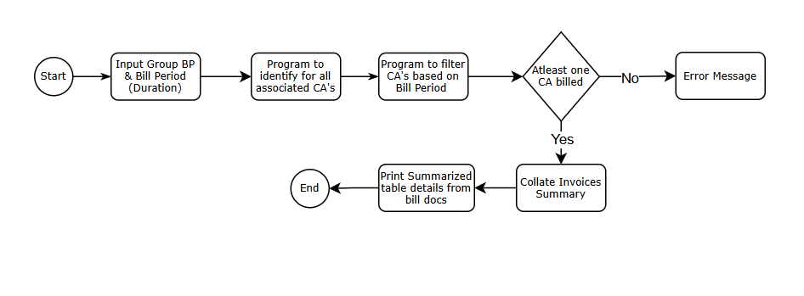

Processing Logic
STEP 1 : Enter all the required values in the selection screen.
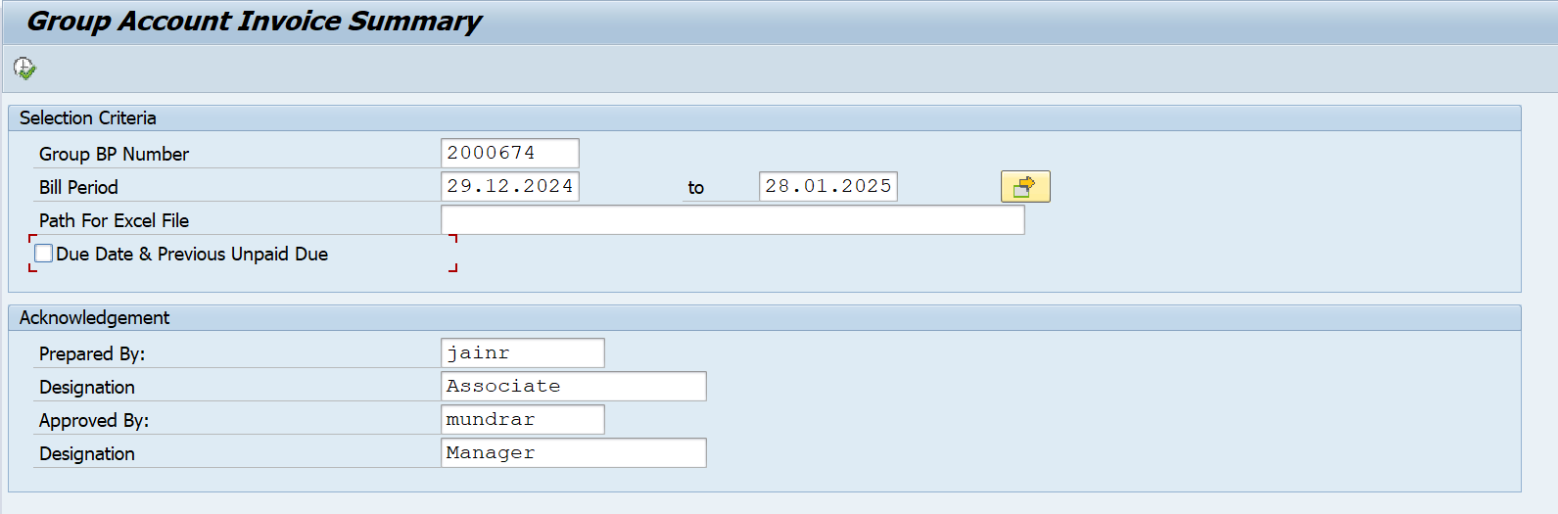

STEP 2 : Final Invoices are printed in the form of an alv.
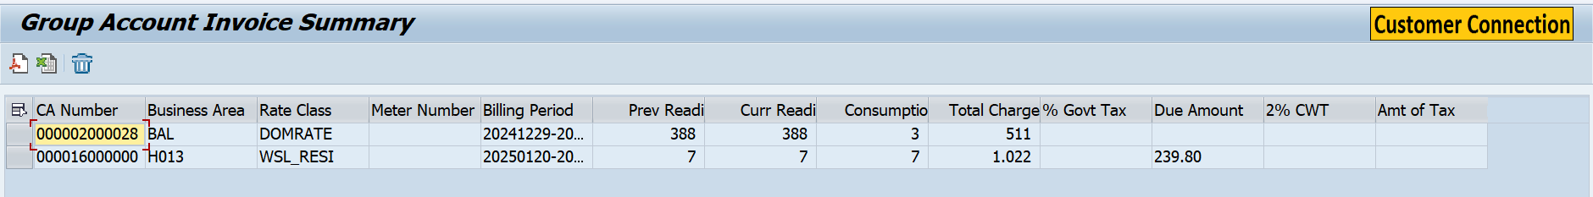

STEP 3 : Download the final alv to your system

Error handling
N/A

BRF Details
N/A

Fiori Extension
N/A

Cloud Extension
N/A

Custom DDIC Objects
N/A

Custom Business Object Details

Custom Business Object Name
Field Name | Type | Length

Custom CDS Views Details

Custom CDS View Name
Primary View
Associated Views

Custom Field details

Custom Logic/Enhancement Details

Enhancement Name
Logic

Custom Reusable Elements (Code-list, Library)

Custom Code list
Used in

Custom Library Name
{Method_Name} | {Logic}

Form & Email Extensibility

Form Templates
Email Templates
Data Source Details

Messages
Message Class | Message ID | Message Text

Subroutines
Name | Description

Assumptions in Technical Design
N/A

Open Issues in Technical Design
N/A

Unit Test Results
Scenario # | Input Selection Criteria | Expected Result | Actual Test Pass/Fail
1 | Provide Group BP with End Bill Date Range where Associated CA Invoices are all billed for this month. Company code not equal to MWCI or M001 | Program creates an invoice summary report according to summary provided by Non East Zone | Pass
2 | Provide Group BP with End Bill Date Range where a few BPs are billed for this month. | Program creates an invoice summary report | Pass
3 | Provide Group BP with End Bill Date Range where all Business Partner are all billed for this month. | Program creates an invoice summary report according to summary provided by East Zone | Pass
4 | Provide Group BP with End Bill Date Range where Associated CA Invoices are all billed for this month. Company code not equal to MWCI or M001 | Program creates an invoice summary report according to summary provided by Non East Zone | Pass
5 | Provide Group BP on selection screen where Identification doesnot exists | Generates an error message for invalid Business Partner. | Pass

Related Documentation

Template Version
Version | Status | Date | Version Created by (Name/E-Mail/Company) | Role | Comments
1.0 | Final | February 11, 2019 | Abhishek Nayak | Author
1.1 | Final | March 15, 2022 | Abhishek Nayak | Author | Updated to include In-App Extension artifacts like Custom logic, Custom Fields, Custom BO, Custom CDS Views, Custom Code list, Libraries, Form & Email Extensibility.

